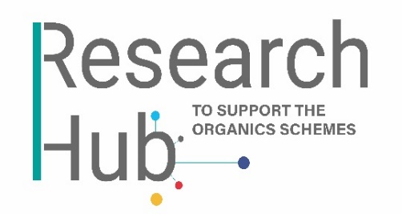
Research Proposal Submission Form

Please complete this form should you wish your research idea to be considered by the Research Hub for commissioning.
N.B. The submitter of a Research Project Proposal (if selected for commissioning) will not automatically be appointed to carry out the work, though that submitter will have the opportunity to tender for the work, should they wish.
- Your details:

Title(s)
First name(s)
Surnames(s)
Email(s)
Telephone(s)
Organisation(s)

- About the project:

Project title (max. 25 words)
Description of the proposed work (max. 250 words)
Brief statement of objectives, methodology and outcomes:
- Objective(s) (max. 60 words)
- Methodology (max. 60 words)
- Aim(s)/outcome(s) (max. 60 words)
Perceived relevance to the Compost Certification Scheme (CCS) and/or Biofertiliser Certification Scheme (BCS):
CCS BCS CCS & BCS
Benefit(s) for relevant schemes:

Once finished, please send your form to Olivia Furssedonn (Research Hub Manager) using olivia@realschemes.org.uk. You will receive an email from REAL to confirm safe receipt of your proposal document.

